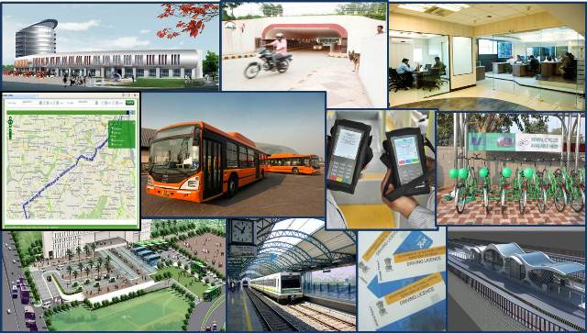

**Company Profile**

**Delhi Integrated Multi-Modal Transit System Limited**

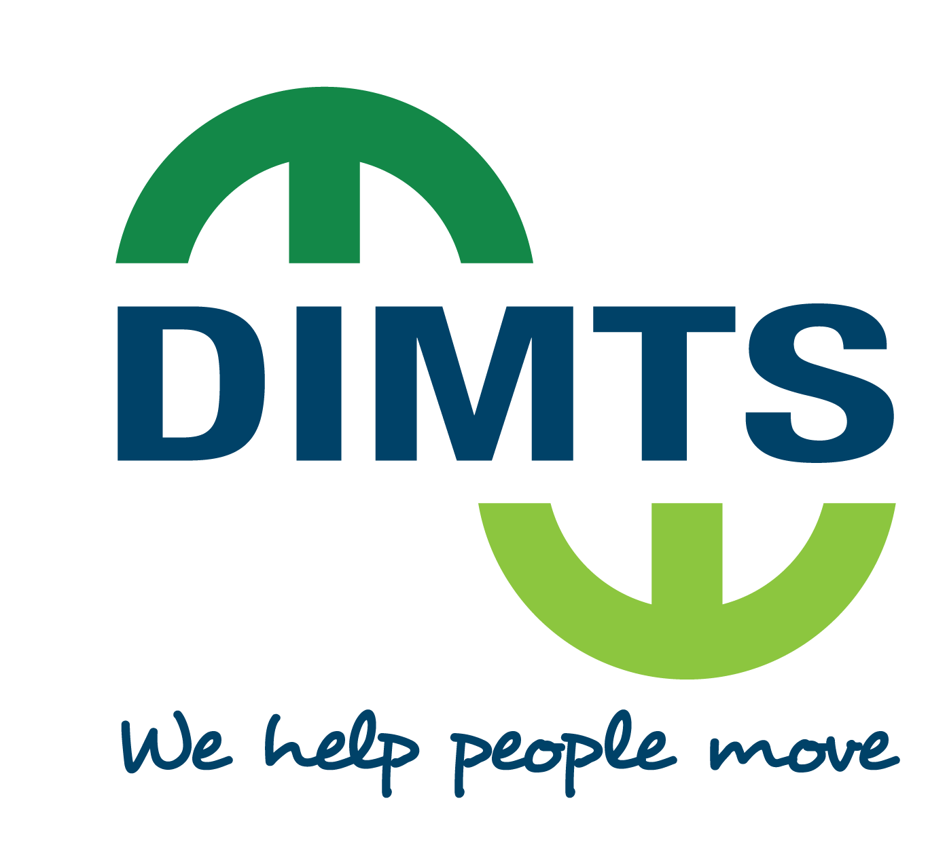

**1st Floor, Maharana Pratap ISBT Building, Kashmere Gate, Delhi – 110006 (India)**

Phone: +91–11 – 43090100, Fax: +91–11 – 23860966

**Email: info@dimts.in; Website:** [**www.dimts.in**](http://www.dimts.in)

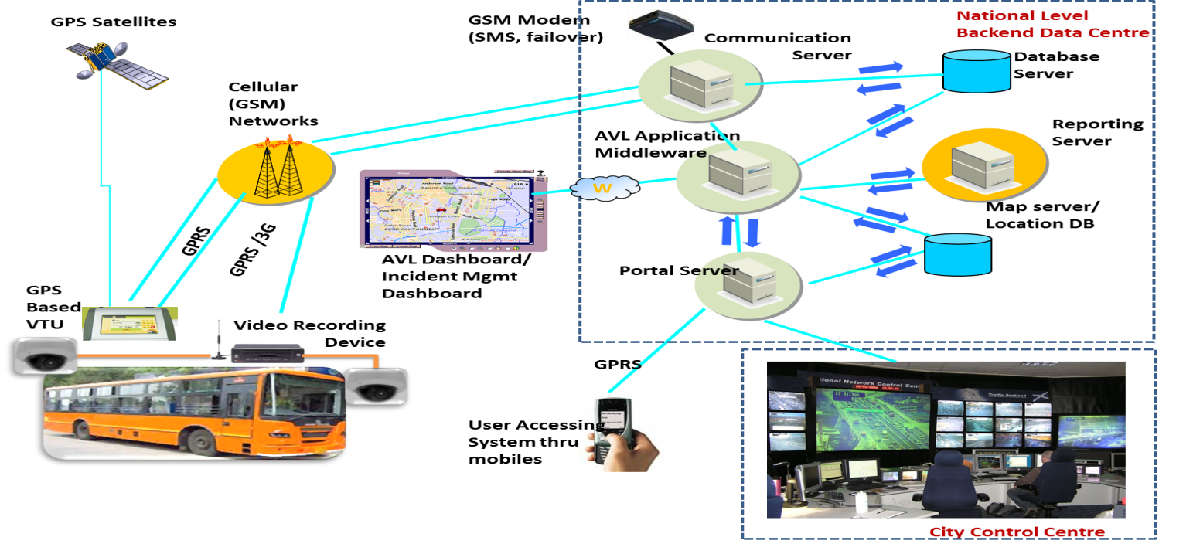**.**

**Delhi Integrated Multi-Modal Transit System (DIMTS) Limited** is an Urban Transport and Infrastructure Development Company committed to delivery of quality services. It is a Joint Venture Company with equal equity of the Government of National Capital Territory of Delhi (GNCTD) and the IDFC Foundation (a not-for-profit initiative of Infrastructure Development Finance Company Limited). We provide Concept-to-Commissioning Consultancy, Intelligent Transport System Solutions and Urban Transport Asset Management Services.

The DIMTS team consists of multi-disciplinary team of professionals to super-specialist drawn from diverse fields of Transport Planning, Financial and Transaction Advisory, Engineering Construction and Project Management (including Railway Engineering), Operations and Information Technology, amongst a few others

DIMTS is an ISO 9001, 14001, OHSAS 18001,ISO 27001 & CMMI L3 Certified Company

## Our Vision, Mission and Goal

|  |  |
| --- | --- |
| **Vision** | To provide an efficient multi-modal transport system that will encourage commuters to choose public transport over personal transport. |
| **Mission** | To establish new standards of excellence in public transportation and allied infrastructure systems that will keep pace with the growth in demand. To provide reliable, safe, accessible, user - friendly and sustainable public transport within walking distance for commuters. |
| **Goal** | To achieve the vision and mission by 2020 in a financially sustainable manner. |

## Areas of Expertise

DIMTS has consolidated its activities into five major areas:

**Transport Technologies**

* Comprehensive mobility planning
* Route Rationalization
* Urban Mass Transit Corridor Planning and Design
* Traffic simulation
* Feasibility Analysis
* Project Structuring
* PPP Advisory
* Bid documentation
* Bid process management
* Bus Concession Management
* BRT Corridor Management
* Operations Control Centre
* Smart-card issuance management

**Transport Planning**

**Advisory Services**

**Railway / Engineering**

**Operations**

* Automatic Vehicle Location
* Electronic Ticketing
* Passenger Information Systems
* Intelligent Signalling
* Identity Management
* Design
* Project Management
* Construction Supervision
* Independent Engineering Services
* Railways
* Alignment and Track design
* Signaling

### **Board of Directors**

|  |
| --- |
| **Dr. M. M. Kutty,** IAS, Chief Secretary, GNCTD |
| **Mrs. Varsha Joshi,** IAS, Secretary cum Commissioner (Transport), GNCTD |
| **Mr. Rakesh Bali,** IAS, Special Secretary (Finance), GNCTD |
| **Mr. Dinesh Mohan,** Professor (IIT, Delhi), Nominee, GNCTD |
| **Ms. Kiran Dhingra,** IAS (Retd.), Independent Director |
| **Dr. O. P. Agarwal,** IAS (Retd.), Independent Director |
| **Mr. Jagan Shah,** Director-National Institute of Urban Affairs, Independent Director |
| **Dr. N. S. Rajan,** CEO-IDFC Foundation, Nominee, IDFC Foundation |
| **Mr. Avtar Monga,** Nominee, IDFC Foundation |
| **Mr. M. Ramsekhar,** Managing Director & CEO |

### **Organization Structure**

### The key management team consists of:

|  |  |  |
| --- | --- | --- |
| **M. Ramsekhar** | : | Managing Director & CEO |
| **Pavitra Roy** | : | Executive Vice President – ITS, TTS and Smart Cities |
| **Ashvini Parashar** | : | Executive Vice President – Business Partnerships |
| **Anurag Somvanshi** | : | Vice President – Business Development |
| **Manpreet Singh** | : | Chief – Road Transport |
| **Samir Kumar Singh** | : | Senior Vice President – Engineering |
| **Samir Kumar Sharma** | : | Vice President – Transport Planning |
| **Rakesh Jain** | : | Vice President – TTS |
| **Manish Kumar** | : | Senior Vice President – IT Strategy |
| **Rajesh Agarwal** | : | Senior Vice President – Railways |
| **Rakesh Kaul** | : | Vice President – ITS |

DIMTS has over 500 personnel many of whom have been drawn from India’s most acclaimed centres of learning (the IITs, IIMs, XLRI, SPA etc.). Our team brings with it a wealth of domain expertise to service clients from various sectors within the mobility vehicles.

## Key Clients

Since its inception in 2006 DIMTS has executed numbers of projects both in domestics and international sections please note a few sample clients list

|  |
| --- |
| **Sample Client References** |
| **International Clients** |
| * Republic of Congo, Government of Congo |
| * Addis Ababa City Roads Authority, Addis Ababa, Ethiopia |
| * Addis Ababa City Government Transport Programs Management Office (TPMO) |
| * Ministry of Urban Development, Water Supply and Drainage, Sri Lanka |
| * Swedish National Road Consulting AB (PMC consultant to Ethiopian Railway Corporation) |
| * Ministry of External Affairs, Govt. of India for Preparation of Detailed Project Report (DPR) for Procurement of Buses with Requisite Infrastructure, Maintenance Support & Training to Miles Bus, Kabul Afghanistan |
| **Domestic Clients** |
| * Transport Department, West Bengal |
| * Chennai Metropolitan Development Authority |
| * JUIDCO Ltd., Urban Development & Housing Department, Govt. of Jharkhand |
| * United Nations Office for Project Services (UNOPS) |
| * The Punjab State Bus Stand Management Company (PUNBUS) |
| * IRCON International Limited |
| * Chhattisgarh Railway Corporation Limited (CRCL) |
| * Kribhco Fertilizers Limited (Shahjahanpur) |
| * Indian Oil Coorporation |
| * Haryana Urban Development Authority (HUDA) |
| * Government of National Capital Territory of Delhi (GNCTD) |
| * Ministry of Urban Development, Government of India (MoUD) |
| * Directorate of State Transport, Haryana |
| * Ministry of Road Transport & Highways (MoRTH) |
| * National Capital Region Planning Board (NCRPB) |
| * Delhi Metro Rail Corporation |
| * Urban Administration & Development Department, Government of Madhya Pradesh |
| * Madhya Pradesh Road Development Corporation Limited |
| * Transport Department, Government of Himachal Pradesh |
| * Transport Department, Government of Puducherry |
| * Tamil Nadu Urban Urban Infrastructure Financial Services Limited (TNUIFSL) |
| * Uttarakhand Infrastructure Development Company (U-Dec) LimiteD |
| * Maharashtra State Road Development Corporation (MSRDC) |
| * Indian Railway Station Development Corporation Ltd. (IRSDC) |
| * Municipal Corporation of Delhi (MCD) |
| * New Delhi Municipal Council (NDMC) |
| * Naya Raipur Development Authority |
| * New Okhla Industrial Development Authority |
| * Mumbai Metropolitan Region Development Authority (MMRDA) |
| * Ahmedabad Municipal Corporation |
| * Haryana Urban Development Authority (HUDA) |
| * Surat Municipal Corporation |
| * Public Works Department (PWD), Government of National Capital Territory of Delhi (GNCTD) |
| * Unique Identification Authority of India (UIDAI) |
| * Delhi Jal Board |
| * [Container Corporation of India Ltd.](http://www.concorindia.com/) (CONCOR ) |
| * Bhopal Municipal Corporation |
| * Municipal Corporation, Gurugram |
| **Private Clients** |
| * Shakti Sustainable Energy Foundation |
| * Larsen & Toubro Ltd. |
| * GMR Infrastructure Ltd. |
| * Moser Baer Power Ltd. |
| * [Hindustan Construction Company Ltd.](http://money.rediff.com/companies/hindconstructionco/11600006) |
| * SMS Infrastructure Ltd |
| * Piramal Roads Ltd. |
| * DS Construction Ltd. |
| * iDeCK |
| * TATA Road Projects Limited |
| * DIAL (Delhi International Airport (P) Limited) |
| * TRIL Roads PVT. LTD. |
| * Baharampore Farakka Highways Ltd |

**DIMTS’ Memberships and Partnerships**

With an intent to provide a multi–disciplinary approach towards development of transportation infrastructure initiatives, DIMTS has structured alliances with leading organizations in the field of urban transportation and infrastructure, research. Few such examples are as follows

|  |  |
| --- | --- |
|  | **Transportation Research & Injury Prevention Programme (TRIPP), IIT, Delhi** |
|  | **International Association of Public Transport** |
| [Description: See full size image](http://www.trl.co.uk/enviro_pages/A40_Cheltenham_files/trl_logo3.jpg) | Transport Research Laboratory, United Kingdom |
| [Description: http://t0.gstatic.com/images?q=tbn:pJNMdvDNw03aZM:http://www.indiaprwire.com/downloads/photo/200909/9795.png](http://www.google.co.in/imgres?imgurl=http://www.indiaprwire.com/downloads/photo/200909/9795.png&imgrefurl=http://www.indiaprwire.com/pressrelease/food/2009091834028.htm&usg=__HrBJRspeb65Nlt5wRcBP8pi37TM=&h=204&w=200&sz=34&hl=en&start=3&zoom=1&tbnid=pJNMdvDNw03aZM:&tbnh=105&tbnw=103&prev=/images?q=iit+delhi+logo&um=1&hl=en&tbs=isch:1&um=1&itbs=1) | **Indian Institute of Technology, Delhi** |
| Description: http://www.topnews.in/files/indian-railway_0.jpg | **Indian Railways** |
| Description: http://www.hospitalinfra-india.com/g/2010/logos/CEAI_LOGO_resized.jpg | **Consulting Engineers Association of India** |
|  | **Institute for Transportation & Development Policy (ITDP)**  **New York, NY, 10001 USA** |
|  | **Automotive Research Association of India (ARAI)**  **Pune** |

**Awards and Achievements**

Few of DIMTS Awards listing:

* Award for Excellence for Best Intelligent Transit System by MoUD, Govt. of India
* Awards for Excellence for Best Non-Motorized Transport by MoUD, Govt. of India
* Regional Award for Restructuring of Private Stage Carriage Buses by UITP
* Awards for Excellence for Best PPP initiative in Urban Transport by MoUD, Govt. of India
* Award for Excellence for Best Cycle Rickshaw / Cycle Transport by MoUD, Govt. of India
* Awards for Best ICT Solution in Transport Sector by NASSCOM
* UITP Youth Award 2009 (Special case for action) for Delhi BRT by UITP
* Appreciation Award given by Delhi Government for keeping Delhi pollution free during ODD-EVEN policy, 2016
* **SKOCH Mobility Awards, December 2016**
* Corporatization of Private Stage Carriage Services in Delhi in Gold Category
* Kashmere Gate Multi Modal Transit District in Gold Category
* **SKOCH Order-Of-Merit for qualifying among top 100-Projects**
* Kashmere Gate Multi Modal Transit District
* Corporation of private stage carriage services in Delhi
* Implementation of Innovative parking Management System in India
* **“Best Workplace Practices” award by World HRD Congress** at the 25th Global HR Excellence awards 2017 held on 15th February, 2017 at Taj Land End, Mumbai
* **World HRD Congress ‘HR Leadership’ Award 2017**
* **Niti Ayog, Rocky mountain Institute,** Feb. 2017 for Transformative Mobility Solutions for India

**OUR KEY PROJECTS & SERVICES**

**Transport Planning**

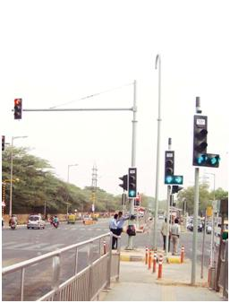**Key Services**

* Traffic Modeling and Micro Simulation Studies using software like VISSIM, Trans Modeler, Cube VOYAGER, VISUM and TRANSCAD
* Comprehensive Mobility Plans
* Traffic Surveys and Impact Assessment Studies
* Bus Route Rationalization and Feeder Network Planning
* Planning, Design and Feasibility of Public Transit Systems
  + Bus Rapid Transit System
  + Rail Rapid Transit
  + Mono Rail
  + Personal Rapid Transit
* Signal Design and Optimization Studies
* Traffic Studies and Capacity Analysis for Feasibility/DPR Studies of Roads/Bridges/Flyovers/Grade Separators/ROBs

*Traffic modeling and impact assessment*

* Traffic Management Plans including Parking Management
* Preparation of Road Master Plan
* Circulation Planning for Terminal  Facilities
* Traffic and Revenue Forecast Studies
* Pre-tender/Post-tender/Investment Advisory Services
* Street-scraping and Urban Design

**Key Projects**

* Feasibility and Operational Planning Study for a Bus Rapid Transit (BRT) System, Addis Ababa, Ethiopia
* Development of Public Transport System in the Republic of Congo
* Detailed Project Report & Project Management Services (PMS) for BRTS in Nagpur City under JNNURM, India
* Feasibility Study Report of 6 BRTS Corridors in Delhi, India
* Detailed Project Report (DPR) for Six other BRTS Corridors in Delhi
* DPR for Regional Rapid Transit System for two Corridors - Panipat-Sonepat-Delhi (110 km) & Meerut-Ghaziabad-Delhi (90 km)
* Route Rationalization of all the bus routes in Delhi through a DPR
* Traffic Simulation Study for CONCOR ICD at Tughlakabad; Micro Simulation of Traffic at Dayal Chowk; Preparation of Area Development Plan for Buddha Smriti Udhyaan Development, Govt. of India
* Technical and Financial Feasibility Study for MMRDA Mumbai;
* DPR for LRTS System in Bangalore for Bangalore Airport Rail Link Limited
* Feasibility Study for Personal Rapid Transit in Delhi, India
* Comprehensive Mobility Plans for Bhopal, Dehradun, Mussoorie, Rohtak, Thoottukudi (Tamil Nadu), Puducherry, Ranchi in India

**Transportation Technology and IT Solutions**

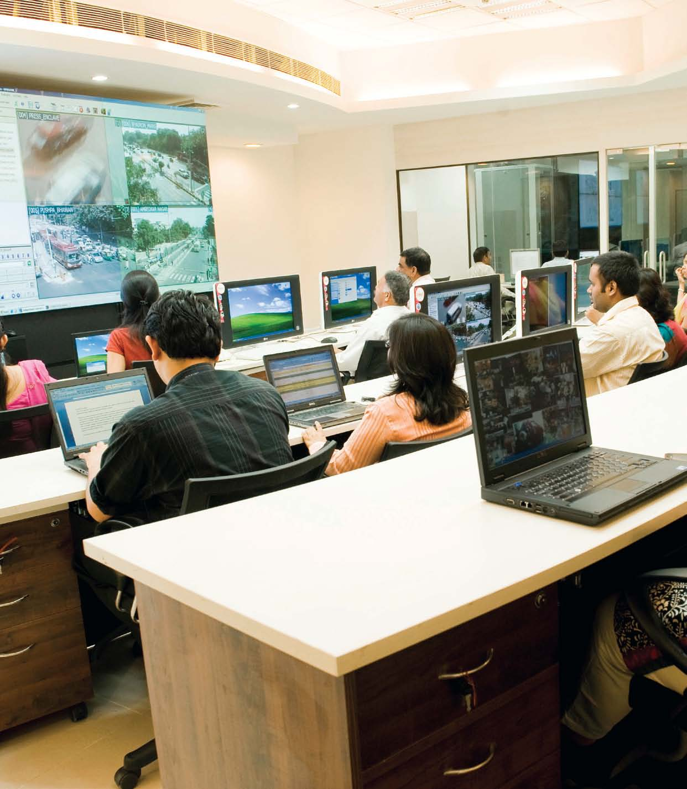**Key Services**

* Intelligent Transportation System
* Vehicle Tracking and KPI Management of Mobile Assets
* Smart Card Applications
* Hand-Held Device based Applications
* RFID and NFC technologies
* Convergent delivery model based e-Governance Solutions
* Integrated Transport Vehicle Operations and Management Systems

*Our Operations Control Centre at Kashmere Gate*

|  |
| --- |
| **Key Projects**   * Program Management of Implementing National Level Vehicle Security & Tracking System and City Command & Control Centre - 3 Million public carriage vehicles across 32 cities and setting up National Data centre and operational control centre at National level and at each city. * Traffic Management and Information Control Centre (TMICC) and national Telephone Helpline Operational Manuals * Project Management Consultancy for Intelligent Transport System (ITS) for SUTP Naya Raipur GEF Grant No: TF095549 – IN Project ID: P100589 * Implementation of Automatic Vehicle Location and Tracking System for the entire Public Transit Bus Fleet in Delhi. This is one of the largest Public Transit Fleet Management Projects in the world covering over 55,000 Vehicles * Implementation of a Central Operations Control Room facility for monitoring and management of Public Bus Transit, Fare Collection and Signaling Systems * Implementation of GPRS-based ETM (Electronic Ticketing Machines) based ticketing in Delhi Cluster Buses * Implementation, Operation & Management of Intelligent Signaling System on Ambedkar Nagar-Delhi Gate BRT Corridor * Development, Supply, Installation & Maintenance of ATCS for BRTS Junctions in Surat City * Restoration & Repair of Signalized Intersections and Up-gradation of Signalling Control Center * LED Display driven Commuter Interface Systems * ERP based Bus Operations and Management System * Depot Management Application * Development of Computerized Learners’ License Testing and Issuance System * Smart Transport Applications Designed for large events with Impacts on Urban Mobility – a demonstration project funded by the European Union to develop Best Practices for transport management during mega-events |

**Transaction Advisory**

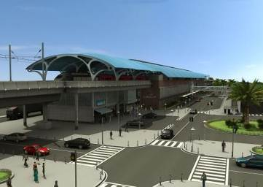 **Key Services**

* Techno-Economic Feasibility
* Financial Analysis
* Business Planning
* Project Structuring
* Bid Process Management
* Debt Syndication

*Regional Rapid Rail – Station Design*

**Key Projects**

* Detailed Feasibility Studies for Urban Rail Systems
* Regional Rapid Transit Systems: Delhi – Panipat and Delhi – Meerut Corridors
* Monorail systems in Delhi and Mumbai
* Light Rail Transit (LRT) Systems in Delhi and Bangalore
* Personal Rapid Transit (PRT) Systems in Delhi and Mumbai
* Business Planning for Development of Multi-Modal Transit Centers (MMTC) on a self-financing format
* Project Structuring and Transaction Advisory for Privatization of Bus Services in Delhi. *Nine project packages (“clusters”) for privatized bus operations in Delhi have been successfully bid out*
* Debt Syndication
* Raised debt of more than Rs. 500 Crores for three projects
* Feasibility Studies, Project Structuring and Transaction Advisory for Infrastructure Projects
* Urban Street Furniture (Bus Shelters, Cycle Stations, Foot-Over-Bridges, Public Convenience Zones etc.)

**Bus Transit Concession Management**

**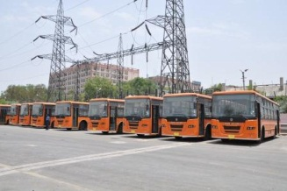  
Key Services**

* Project Conceptualization
* Feasibility Study
* Economic Analysis & Business Modeling
* Bid Process Management
* Contract Management
* Operations Management

*View of Private bus cluster depot*

**Key Project**

* **Corporatization of Private Stage Carriage Buses in Delhi**

This scheme was conceptualized and drafted by DIMTS on behalf of GNCTD. DIMTS also has the single point responsibility to monitor the operations of these buses.

The scheme involved dividing 657 Stage Carriage Bus Routes of Delhi into 17 Clusters. Each Cluster is to be serviced by a single private operator and DTC, the State Transport Corporation, under a Unified Time Table (UTT). Each Cluster has a combination of high, medium and low demand routes. DIMTS also monitors the quality of service and has put in place a performance incentive regime to reward or penalize the operator on the basis of the quality of service delivered.

As of April, 2014 there are around 1350 Delhi Transit buses operating under this scheme on the roads of Delhi. This fleet is expected to grow to 5500. Close and rigorous monitoring of performance through use of technology and data analytics help in providing safe, reliable and punctual public transportation services in a cost – effective manner.

In Delhi, as compared to the public sector service provider, cluster buses, whose concession is being managed by DIMTS, help in saving costs of service provision by whopping margin of 45%.

**Operations and Management**

**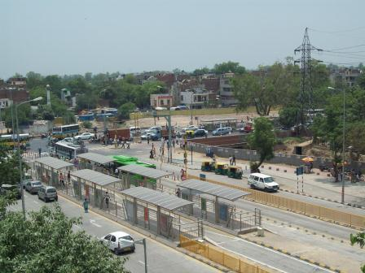  
Key Services**

* Project Management
* Asset Security and Management
* Process Management
* Traffic Management
* Safety Audit

*View of BRT Corridor being managed by DIMTS*

**Key Projects**

* Operation and Management of the BRT Corridor from Ambedkar Nagar to Moolchand.
* IT enabled Learner Licence Testing
* Issuance of Smart Card based Driving License and PSV Badges in Delhi
* Issuance of Smart Card based Permits for Three-wheeled Scooter Rickshaws (TSR)
* Enrollment Services for Unique Identification Development Authority of India (UIDAI)

**Infrastructure Development and Engineering**

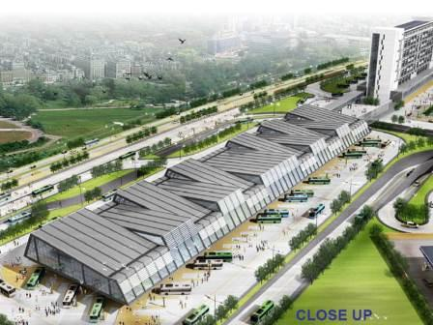**Key Services**

* Project Management Consultancy
* Independent Engineer
* Engineering Surveys and Investigations
* Third Party Quality Inspection
* Design Reviews and Value Engineering
* Rehabilitation and Up-gradation of existing assets
* Turnkey Execution
* Operations and Maintenance
* Techno-Economic Feasibility Study
* Detailed Engineering Design
* Engineering Estimation and Costing

*Bird’s Eye View of Sarai Kale Khan Multi-Modal Transit Centre*

**Key Projects**

* Preparation of Technical and Financial Feasibility Study, Master Plan, Business Plan and Providing Transaction and Bid Advisory Services for Development / Redevelopment of Anand Vihar (New Delhi) Railway Station on the Indian Railway Network”
* Engineering studies for re-development/development of Multi-Modal Transit Centers - Kashmere Gate,Sarai Kale Khan, Anand Vihar, Dwarka
* Design and Construction of Depot facilities - Millennium Depot, Kanjhawala Depot, Sunheri Nallah Depot
* Construction of FOBs/Subways/Bus Shelters at several locations in Delhi
* Construction of Parking Facilities at several locations in Delhi
* Independent Engineer for Automatic Multi-level Car Parking at two locations in Delhi - Baba Kharag Sign Marg (1408 cars), Sarojini Nagar (824 cars)
* Technical Consultancy Services for Construction of Half Flyover and U-Turn in front of Sector-15A, Noida
* Technical Consultancy Services for Construction of Foot Over Bridges at 13 Different Location in Noida

**Railway Engineering**

**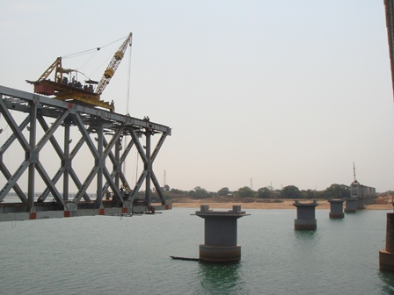  
Key Services**

* Project Management Consultancy
* Bid Process Management
* Contract Management
* Execution and Commissioning
* Detailed Design Engineering
* Value Engineering

*Doubling between Salka Road – Khongsara*

* **IRCON:** Preparation of Detailed Project Report in Connection with Construction of New BG Electrified Double Line in the State of Chhattisgarh Over South East central Railway Corridor-III: East West Corridor- Gevra Road to Pendra Road Via Dipka, Kathghora, Sendurgarh and Pasan approximately 122 Km in length
* **IRCON:** Consultancy Services for the Work of Preparation of Detailed Project Report in Connection With Construction of New BG Electrified Double Line in the State of Chhattisgarh Over South East Central Railway Corridor-I: East Corridor- Dharamjagarh to Korba approximately 62 Km in length.
* **IRCON:** Providing Consultancy Services to carry out Feasibility Study, PETS, Topographical Survey, Final Location Survey, Preparation of Detailed Cost Estimates, conceptual and Preliminary Design & General Arrangement Drawings of Structures (excluding buildings), Alignment design, assessment of Land requirement and assistance in Land Acquisition and preparation of Detailed Project Report (DPR) including financial viability and bankability of the project between Shivpur to Kathautia (Approx. Length: 49 Km)
* **IRCON:** DPR for Construction of New BG Electrified Double line from Korba to Dharmajaigarh
* **Chhattisgarh Railway Corporation Limited (CRCL)** Consultancy Services for Preparation of Feasibility Study (FS), Detailed Project Report (DPR), and Land Acquisition Works in Connection with New Electrified BG Rail Line from Katghora to Dongargarh in the State of Chhattisgarh in the Jurisdiction of SEC Railway (Approximate 270 Km)
* **Kribhco Shyam Fertilizer Limited:** Consultancy Services for DPR, Detailed Engineering and PMC for Railway Siding of Kribhco Shyam Fertilizer Limited, Shahjahanpur, UP
* **Hind Terminal Pvt. Ltd.**: Consultancy services for Rail Infra Works for commissioning of Private Freight Terminal near Kila Raipur, Ludhiana, Harayana
* **M B Power (MP) Limited:** Project Management Consultancy services for construction of private dedicated railway siding from Jaithari railway station of SEC Railway for 1200 MW Thermal Power Plant at Anuppur District MP from Moserbaer Projects, MB Power (Madhya Pradesh) Limited
* **M B Power (MP) Limited:** Detailed Project Report and Project Management Consultancy for Rail Line implementation

**ISO Certifications**



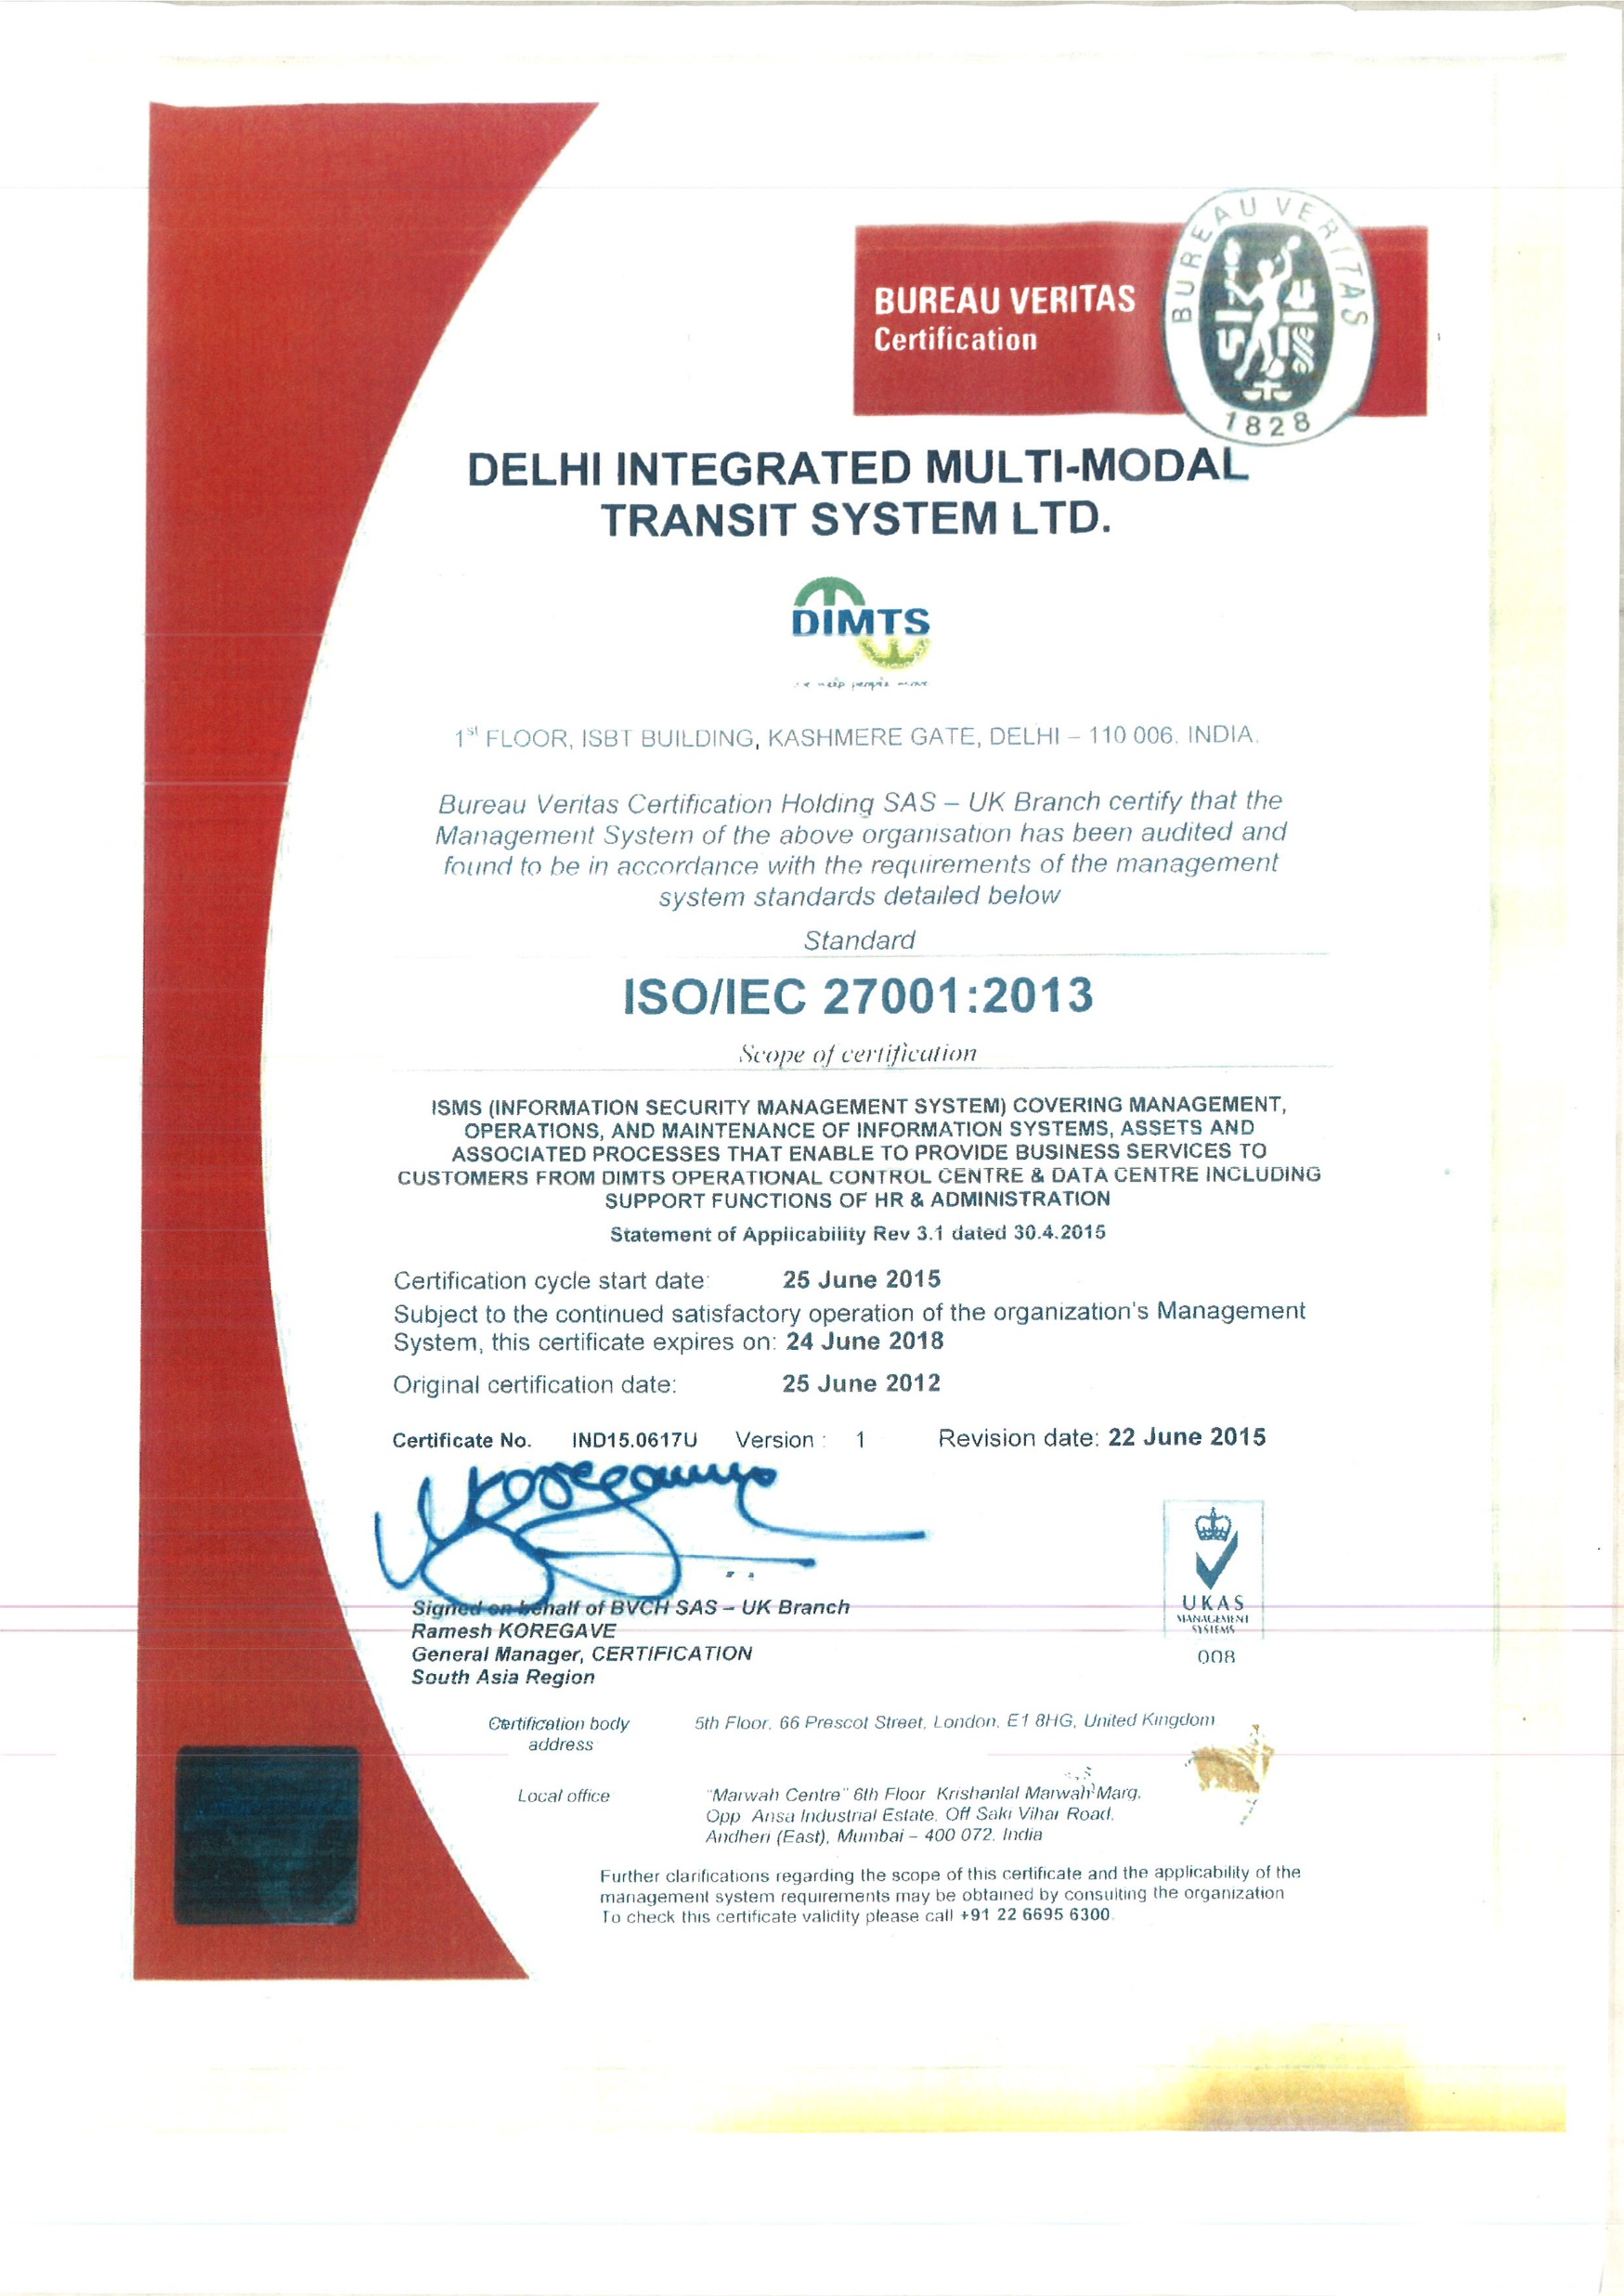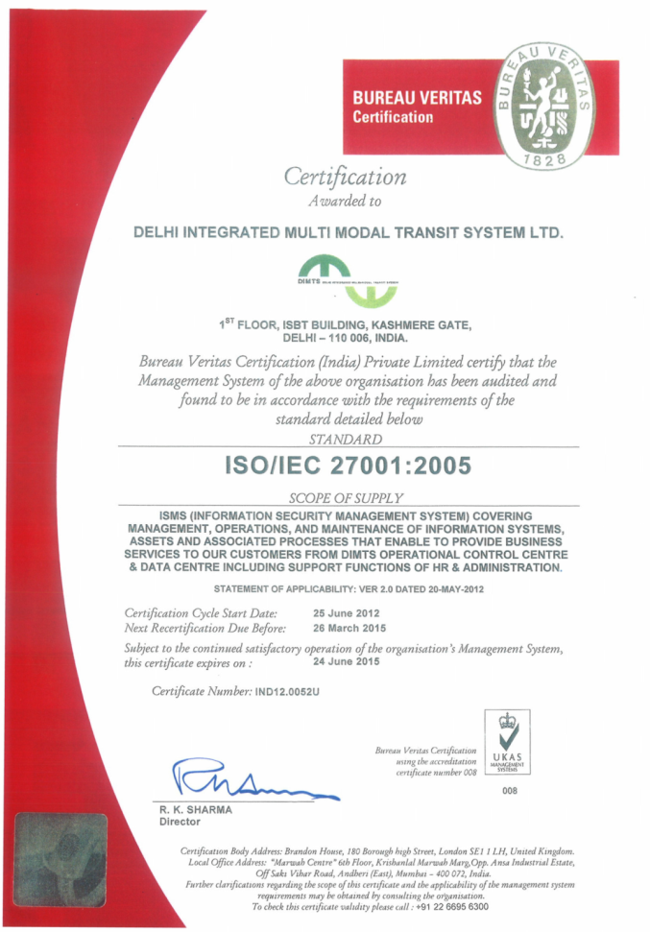



**CMMI L3 Certification**

